//This program is designed to protect processes on Windows XP
//*Rules:
//1.Do NOT run on WinVista Win7 or Win8
//2.PLEASE DO NOT run on WinVista Win7 or Win8
//3. Violating the first two will NECESSARILY lead to the BSoD of your current operating system. (Thanks to the patchguard)
//*How it works:
//By hooking the KeServiceDescriptorsTable(aka SSDT) to intercept the invoke to NtTerminate Process and NtOpenProcess.
//*Instructions
//Please close any anti-virus software since the hooks may conflict with each other.
//On A WINXP system, run DriverLoader.exe, Press Load and choose “ddk.sys” given in the pack.
//Open DeviceControl.exe, enter the PID and press enter.
//Try to terminate it in Taskmgr!
Illustration:
Just to clarify, I did this months ago on a Chinese WINXP.I don’t have winxp available now so I can only show you previous pictures. Some of them are in Chinese but the program is in English. So if possible, run Winxp and check how it works.
1.As we can see, initially, no NtAPI is hooked.
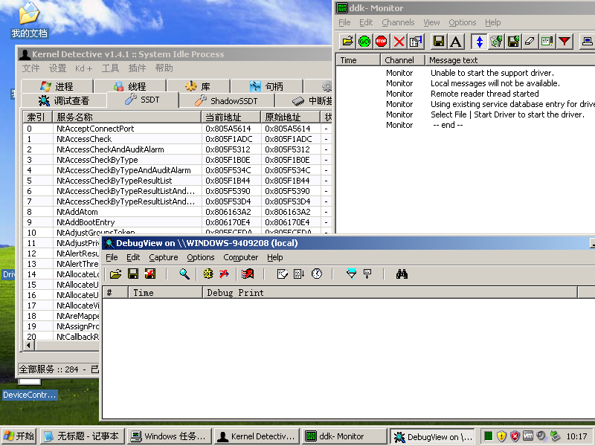

2.Load our driver!!! Two functions are hooked. We can see that the driver prints debug information and we can also see the change of addresses in the Kernel Detective.
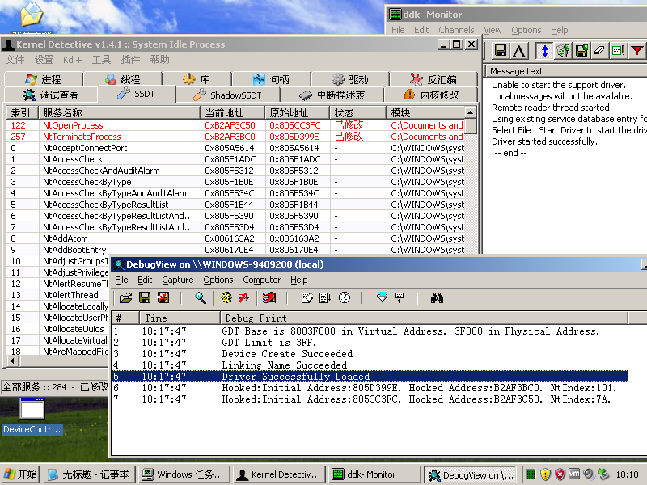

- Let’s do an experiment:
Open notepad and find its PID in taskmgr.
Then open DeviceControl.exe(included in the zip) and type in the PID found.

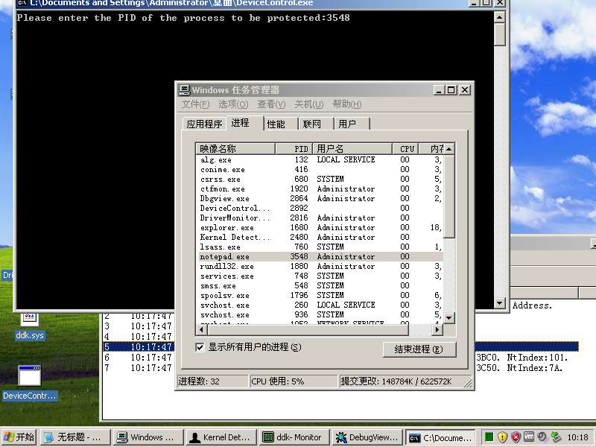

4. As we can see, the driver prints debug information saying that msg received.
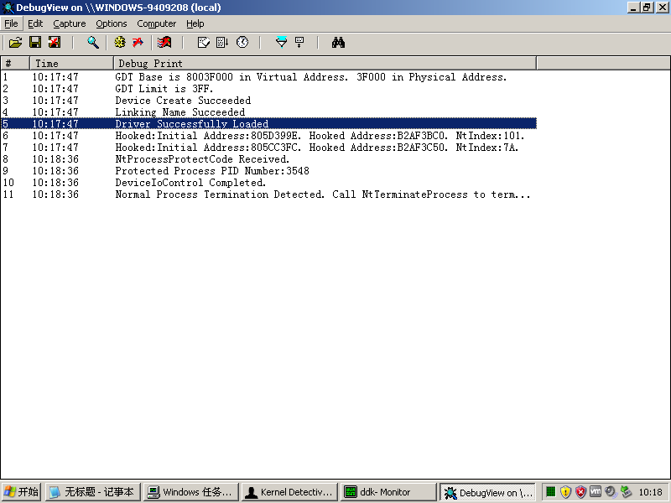
Now let’s try to terminate notepad.exe

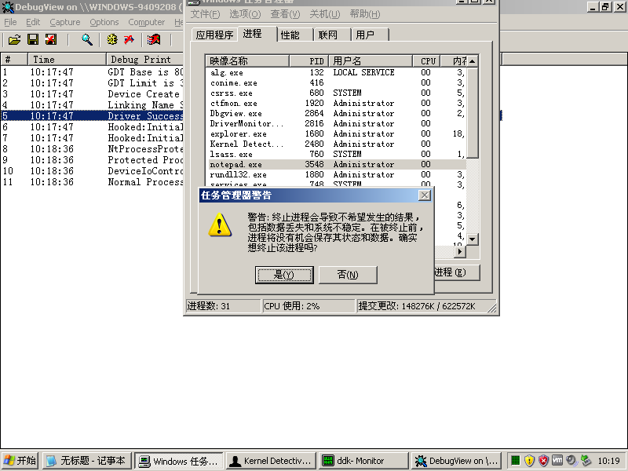
Oops.. It seems that access denied.....
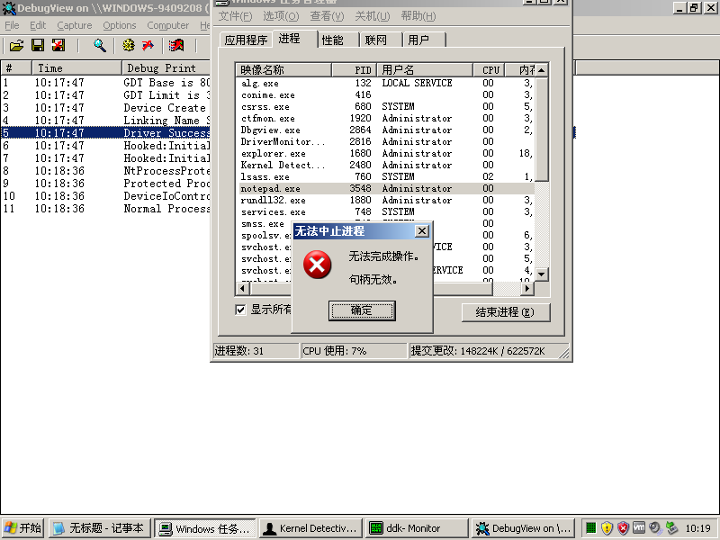
Anyway that’s how my code works!
Remember to unload the driver after using!

